Before Security Fixing
1) OS Command Injection Fix
1a) google.com
Normal behavior (just DNS lookup)
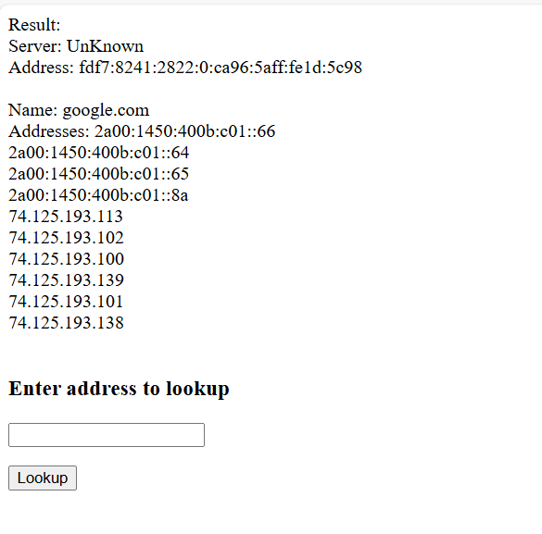
1b) google.com && dir
Directory listing injected
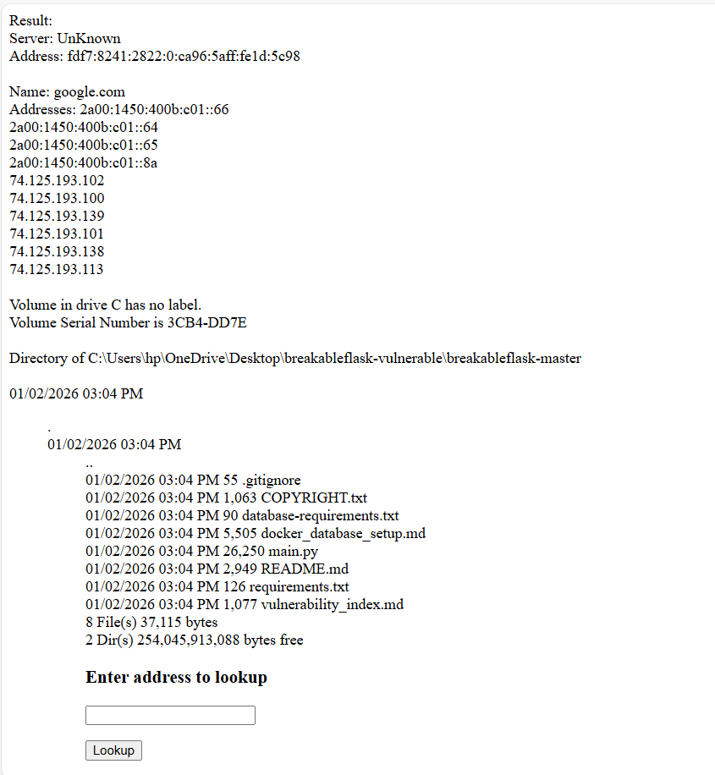
1c) google.com && whoami
Your username displayed
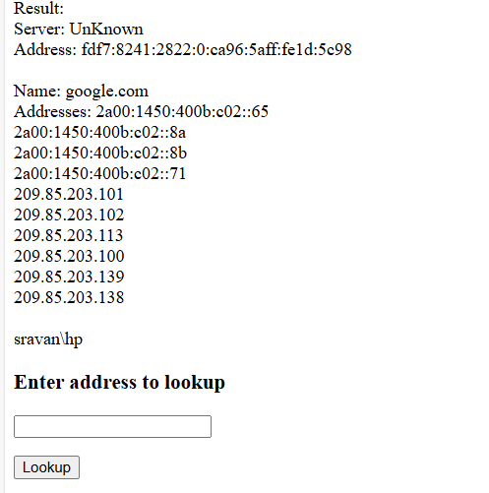

2) SSTI Exploit
2a) Sravan
Getting Greeting normal Hello Sravan !
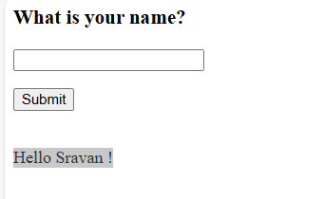
2b) {{7*7}}
Hello 49! (calculated)

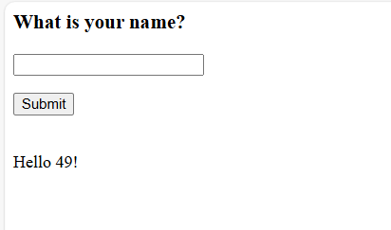
2c) {{7*7+7}}
Calculating 56
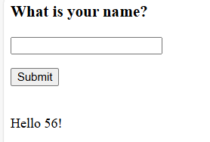
3) Pickle Deserialization Exploit
3a) test value
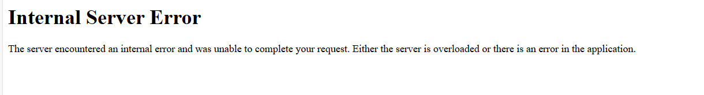
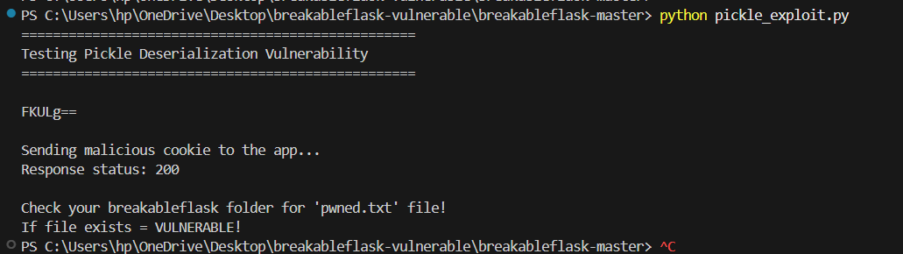

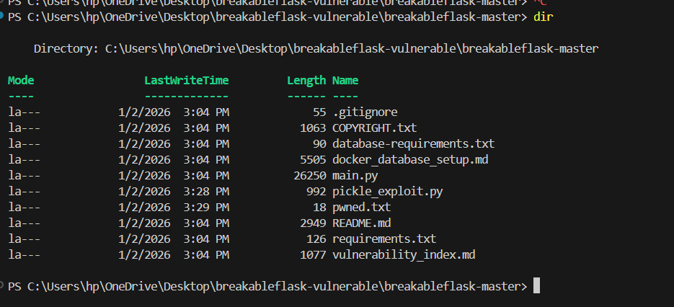

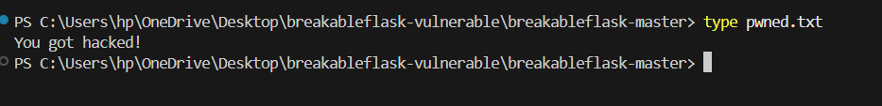

After Security Fixing
1) OS Command Injection Fix
1a) google.com && dir

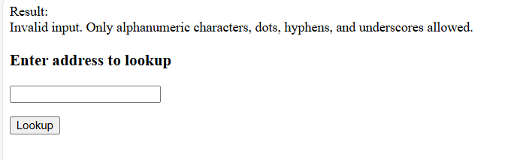

1b) google.com && whoami

2) SSTI Exploit
2a) {{7*7}}

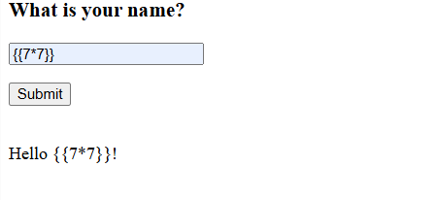

{{7*7+7}}

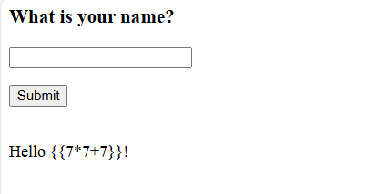

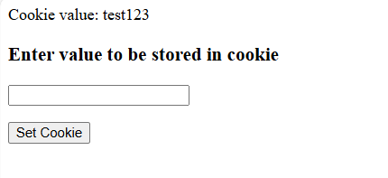

3) Pickle Deserialization Exploit

